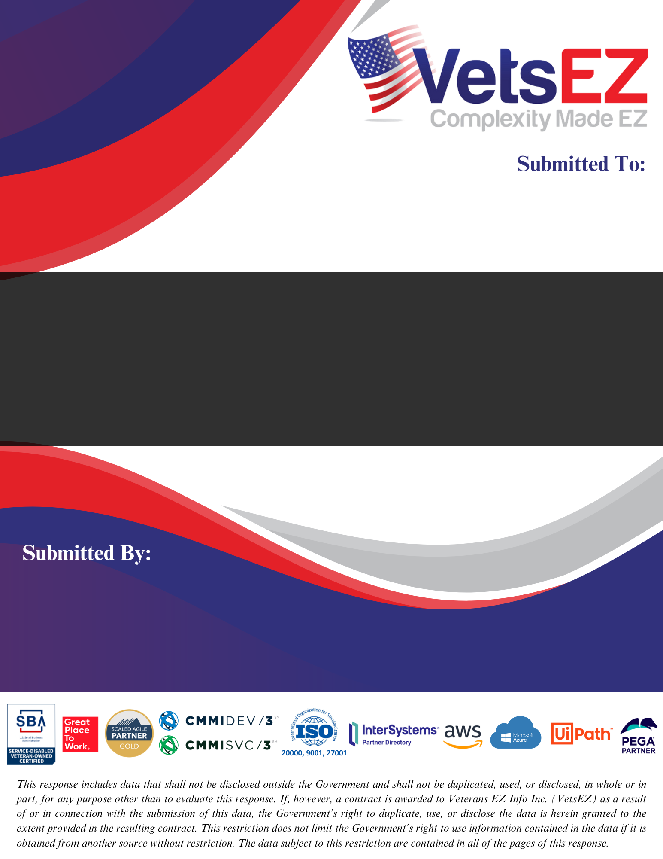

Dana Newcomb, Contracting Officer

Dana.newcomb@va.gov

Sarah Kuna, Contract Specialist

[Sarah.kuna@va.gov](mailto:gary.throckmorton@va.gov)

**VistA Application Analytics**

Technical Volume

­­

**RTEP Number: T4NG-0739**

**August 15, 2024 1:00 PM Eastern**

­­

**DUNS: 078454673**

**CAGE: 6S6R0**

**UEI: HH52KZGMV2Y6**

Veterans EZ Info Inc.

James Miner, President and CEO

+1-619-557-8451

james.miner@vetsez.com

www.vetsez.com

1901 1st Avenue, Suite 192

San Diego, CA 92101

# Table of Contents

1 Introduction 1

2 Understanding 2

3 Technical Approach (RTEP B.1.1) 3

3.1 VistA Client Traffic Capture and Analysis (RTEP B.1.1; PWS 5.2) 5

3.1.1 Capture of VistA Client Traffic (PWS 5.2.1) 6

3.1.2 Analysis of VistA Client Traffic (PWS 5.2.2) 8

3.1.3 Analysis of Use of Key VistA Clients (PWS 5.2.3) 11

3.1.4 VistA Client Use Improvement Report (PWS 5.2.4) 16

3.2 Migrated VistA Client Traffic Capture and Analysis (RTEP B.1.1; PWS 5.3) 17

3.2.1 Migrated VistA Client Traffic Analysis (PWS 5.3.1) 18

3.2.2 VistA Community Care Client Traffic Analysis (PWS 5.3.2) 19

4 Project Task Schedule (RTEP B.1.2) 20

5 Level of Effort (RTEP B.1.3) 25

# Introduction

**Value Additions of Team VetsEZ’s VA2 Solution**

• Our analysis of Remote Procedure Call (RPC) traffic patterns will **optimize clinical workflows**, reducing wait times and improving care for Veterans.

• **Improve the VistA client user interface** by mapping RPC usage to specific screens and tasks, leading to a more intuitive and responsive systems for healthcare providers, ultimately improving care coordination for Veterans.

• Our **RPC analytics** will provide valuable insights into system usage and performance, enabling VA leadership to make informed decisions about resource allocation and system upgrades, improving the quality and accessibility of Veteran care services.

• Our **Clinical Workflow Analytics Framework** will capture a medical center's RPC traffic, generate detailed reports, correlate workflows, and recommend improvements using VA-sanctioned AWS services within the VA Enterprise Cloud (VAEC).

• **Using reusable RPC Extraction scripts to automate and standardize data extraction** from multiple VistA instances, reducing the risk of human error and ensuring uniform data processing for more reliable reports.

• **Automate the generation of reports** to speed up the analysis process, facilitate the application of insights across environments, and enhance the quality and efficiency of subsequent analyses

• **Consolidate Task-Set descriptions** that accurately reflect real-world usage of VistA clients and provide an actionable framework for understanding and optimizing system workflows.

Veterans EZ Info Inc. (VetsEZ) is a Service-Disabled Veteran-owned Small Business (SDVOSB) and a prime contractor on 20 federal contracts amounting to over $815M in contract value. VetsEZ is dedicated to advancing innovative, cost-effective IT solutions for mission-critical systems that provide user-centric support to millions of Veterans. Our unwavering commitment to supporting Veterans and fostering burgeoning small businesses is demonstrated by our past performance score of 19.4 out of 20 **(4.7 out** **of 5.0 in QASP ratings)**, which isamong the **highest of all T4NG prime contractors**. To support the VistA Application Analytics (VA2) TEP, VetsEZ has teamed with HRG Technologies LLC (HRG) to form “Team VetsEZ” (Figure 1). Together, Team VetsEZ has the critical subject matter expertise, hands-on experience, and knowledge to provide effective sustainment and enhancement support for the **VA2** initiative.

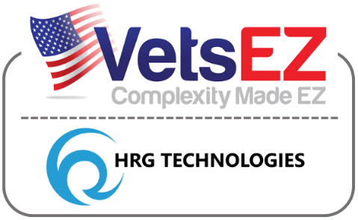

**Figure** **1. Team VetsEZ**

Our team has supported numerous VA mission-critical organizations and projects, including 1) creating and maintaining the VA Joint Legacy Viewer (JLV) contract, which requires understanding the Remote Procedure Calls (RPCs) for accessing a VistA patient record and running services in the VA Enterprise Cloud (VAEC); 2) directly supporting a VistA Data Project for Defense Health Agency (DHA), where we created a cloud-based-framework for analysis acceleration of RPC traffic and use and security to reimplement core VistA services including Vitals, History, and Allergies; 3) directly supported the VA VistA Adaptive Maintenance (VAM) project, in which we analyzed RPC traffic and VistA client usage and security patterns to improve the operation of VistA, and 4) directly supported the VA VistA Data Analytics contract in which we supported Electronic Health Record Modernization (EHRM) and analyzed RPC and HL7 interactions in VistA to inform migration and data harmonization and enrichment to/from VistA into EHRM.

Our team provides a **low-risk**, **cost-effective** solution for VA to execute VA2 with a high degree of success, as demonstrated above by our team’s experience and expertise in non-invasive RPC interface monitoring within the VAEC; comprehensive RPC traffic analysis and authentication method evaluations; VA VistA's RPC interface and extensive knowledge of common VistA clients such as Computerized Patient Record System (CPRS), JLV, and VistA Imaging; and GitHub and VA GitHub practices for efficient code management and documentation using markdown.

# Understanding

VistA usage patterns are crucial for optimizing VA healthcare delivery. Team VetsEZ’s approach leverages RPC traffic and clinical workflow understanding and assessments as a key method to gain this insight. Clinicians' time is the most valuable––Team VetsEZ’s approach **improves clinician workflow by correlating client activity to the resultant RPC traffic and leverages RPC traffic and clinical workflow understanding and assessments as a key method to gain this insight**.

Leveraging the complete RPC Traffic of a medical center for VistA Application Analytics is new and demands a unique approach that marries knowledge of RPC traffic with clinical workflows. Team VetsEZ has experience in each of the tasks required from separate VA projects/contracts: VistA Adaptive Maintenance (VAM) (RPC traffic capture and measurement), VistA Data Project (select RPC sequences from CPRS were re-used in a new web-based client with the same workflow), and VA TeleReader (workflow of VistA client RPC Sequences made to work over Cerner EHR). Collectively, **this experience makes us uniquely qualified for the four parts of VAA** – traffic capture, traffic measurement, clinical workflow correlation, and recommendations to improve workflow. The acceleration of application analytics requires a comprehensive approach to analyze and improve VistA clinical workflows. As depicted in Figure 2, we must capture RPC traffic from clinical clients, storing it in a continuously updated RPC Traffic Knowledge Repository. This data must then be correlated with workflows obtained from documents in the VHA's VistA Document Library (VDL), allowing us to map the user actions of clinical clients to underlying clinical workflows. From this analysis, we must generate detailed Task-Set Descriptions that provide insights into how user interactions translate into data flows (traffic to/from VistA). Our clinical Functional Area SMEs must interpret these descriptions to identify improvement opportunities and develop actionable recommendations.

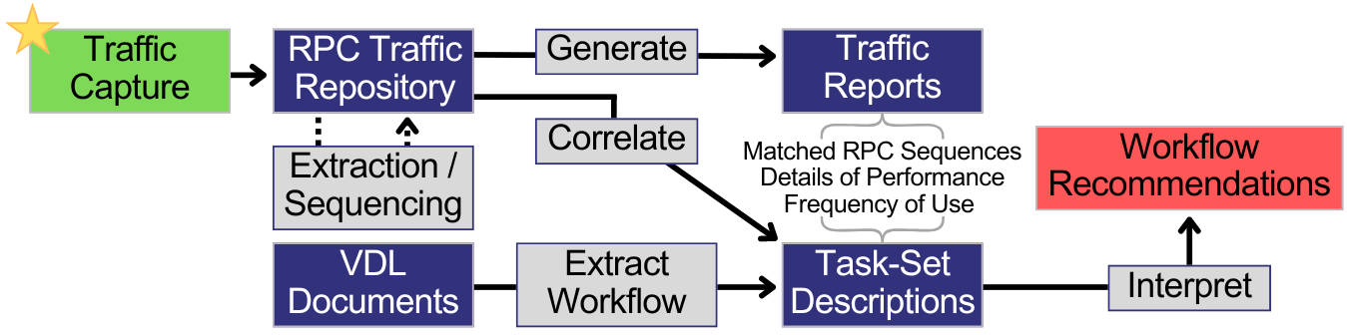

**Figure** **2. Team VetsEZ’s Understanding of Vista Application Analytics Acceleration Stages**

Team VetsEZ is committed to supporting the VistA Application Analytics (VA2) TEP, which seeks to enhance the understanding of healthcare data traffic between VistA clients and selected VistA servers. This initiative involves deploying healthcare Data SMEs to thoroughly analyze the interactions, resulting in detailed reports illuminating various aspects of VA care. The assessments encompass structured and unstructured data, specifically focusing on the types and volumes of information accessed by distinct categories of healthcare professionals and the time allocated to various tasks. Among other challenges (Table 1), non-intrusive data capture and correlating clinical workflow tops the list of our approach. Upon completion, VHA will receive a comprehensive set of actionable recommendations and demonstrations to improve the quality of care for Veterans and a framework for conducting similar analyses in the future.

Table 1. Team VetsEZ Challenges, Solution, and Benefits for Successful Delivery of VA2

| Challenge | Solution | Benefits to VA |
| --- | --- | --- |
| Ensuring non-disruptive data collection in a complex, mission-critical environment | * Proven RPC traffic capture and analyzer common information model framework and template in delivering cloud-based VistA analytics collection and assessments * Utilizing non-invasive RPC monitoring | * No impact on existing VistA operations * Real-time data collection without compromising system performance * Comprehensive analytics without risking patient care disruptions |
| Clinical Workflow Correlation | * VetsEZ Kinesis-based RPC-capture, analysis, and correlation of VistA VAEC hosted packages * VetsEZ's traffic analyzer, traffic knowledge repository, VAEC-integrated analytics platform with robust access controls * Describing Clinical Workflows and correlating them to application traffic | * Enhanced data visualization, RPC cataloging, and clinical correlation through end-to-end clinical workflow analysis * Granular analysis and improved audit capabilities for tracking data access and usage * Analysis of traffic patterns to discern areas of concern: frequency of use, disuse, and performance issues |

# Technical Approach (RTEP B.1.1)

Team VetsEZ's advanced analytics modeling of the VistA-CPRS interfaces reveals the underlying operational Veteran Health Data Security Model based on native RPC traffic. This model enables real-time security enforcement and VistA data and traffic monitoring. Leveraging this model, we have developed a Clinical Workflow Analytics Framework, which provides secure, non-intrusive, remote access to Veteran health data from any device, at any time, and from any location. This approach ***significantly*** **enhances data analysis, accelerates RPC analytics, enforces non-intrusive assessments, and provides protection while improving data accessibility for authorized users**, ultimately supporting more responsive and flexible Veteran care delivery. Our technical framework is depicted in Figure 3 below.

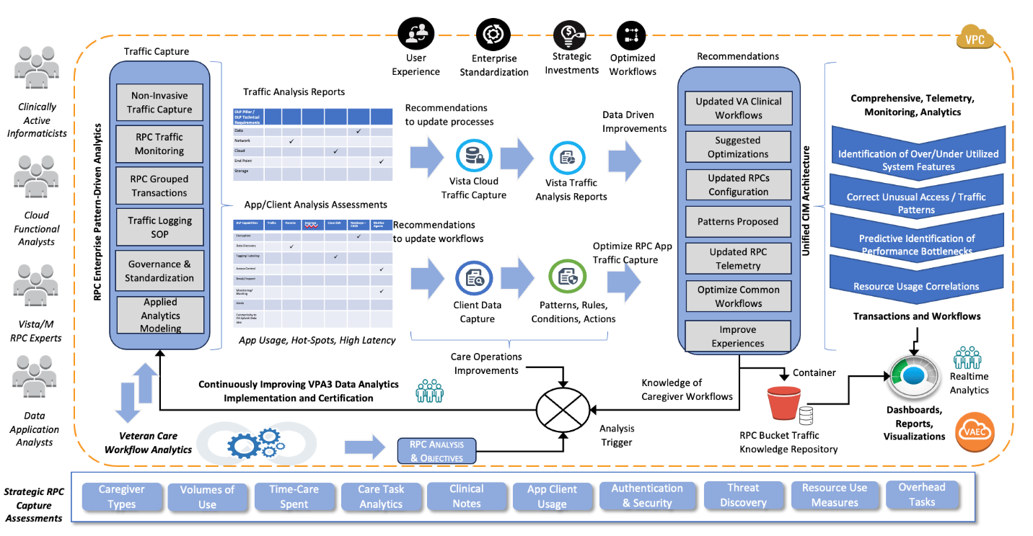

**Figure** **3. Team VetsEZ’s Cloud CPRS RPC-Traffic Capture Framework**

The diagram illustrates a strategic framework for RPC capture assessments focused on improving clinical workflows and system performance within a healthcare environment, specifically for Veteran care, capturing a) RPC traffic and b) Application/Client traffic. Below is a summary of the key components:

* **Traffic Capture:** The process begins with capturing traffic data through various methods, including non-invasive capture, RPC traffic monitoring, grouped transactions, and applying analytics models. This traffic data generates analysis reports detailing application/client assessments, including usage patterns, hot spots, and high latency areas.
* **Enterprise Pattern-Driven Analytics:** Leveraging traffic capture data, enterprise-level pattern-driven analytics are applied to generate actionable insights. These insights lead to recommendations for improving processes, updating workflows, and optimizing RPC traffic.
* **Continuous Improvement:** The process is cyclical, with continuous improvement driven by the VA's VA2 Data Analytics implementation and certification. This ongoing process ensures that traffic data is constantly analyzed to trigger operational improvements and optimize care workflows.
* **Unified CIM Architecture:** The analyzed data is integrated into a unified Clinical Information Model (CIM) architecture. This model supports comprehensive monitoring and analytics, identifying under/over-utilized system features, correcting unusual access patterns, predicting bottlenecks, and correlating resource use with outcomes.
* **A blue and black graphic with text

  Description automatically generatedReal-time Analytics and Reporting:** Our output includes actionable recommendations, real-time analytics, dashboards, reports, and visualizations. **These tools support optimizing clinical workflows and resource usage, enhancing the system's overall performance.**

Our team includes Cloud Functional Analysts, RPC Experts, and Data Application Analysts, using this model to deliver a) enhanced user experiences, b) enterprise standardization, c) streamlined data points for strategic investments, and d) optimized workflows. The foundation of our model is based on Strategic RPC Capture Assessments that allow us to understand caregiver types, volumes usage, time spent on patient care, data related to care task analytics, clinical notes assessments, application-client usage, threat discovery analytics, data related to authentication/security, resource usage measures, and overhead tasks data. As part of our technical approach, Team VetsEZ will undertake a comprehensive set of tasks to **enhance and accelerate** the understanding and performance of the VistA packages. These tasks include:

* **Distinction of clinical from non-clinical RPCs:** Identifying and categorizing RPCs based on clinical relevance.
* **Distinction of RPCs that change (write) from those that read the clinical record:** Analyzing RPCs to differentiate between those that modify data and those that solely retrieve information.
* **Distinction of slow-running, high-overhead, and variable-overhead RPCs:** Evaluating RPC performance to identify those that may hinder system efficiency.
* **Clinical care task sets, represented as groups of RPCs used in tandem:** Mapping out sets of RPCs that are commonly utilized together in clinical care scenarios.
* **Match task sets with one or more specific client screens:** Correlating identified task sets with the specific client interfaces they utilize.
* **Task sets employed by different user types:** Analyzing how various user categories interact with the system through distinct task sets.
* **Isolate performance issues with patterns of use that slow care:** Identifying usage patterns that contribute to delays in care delivery.
* **Verification and validation that the analysis accurately captures care provision:** Ensuring that the findings of our analysis reliably reflect the actual care processes in place.

Through these tasks, VetsEZ aims to provide actionable insights to enhance the efficiency and effectiveness of care delivery within VHA.

## VistA Client Traffic Capture and Analysis (RTEP B.1.1; PWS 5.2)

The VetsEZ VistA Point of Care Accelerated Application Analytics framework revolutionizes healthcare delivery for Veterans by addressing the critical need for efficient clinical workflows. Recognizing that clinician time is the most valuable commodity in the VHA healthcare system and a primary factor in determining Veteran access to care. Our solution provides the first-ever comprehensive, real-world transactional traffic monitoring and analytics on VistA Point of Care Applications. This cloud-native, data-driven framework (Figure 4), built on the VAEC, enables us to capture and analyze all transactional traffic flow across VistA applications, similar to Cerner's "Lights on Network."

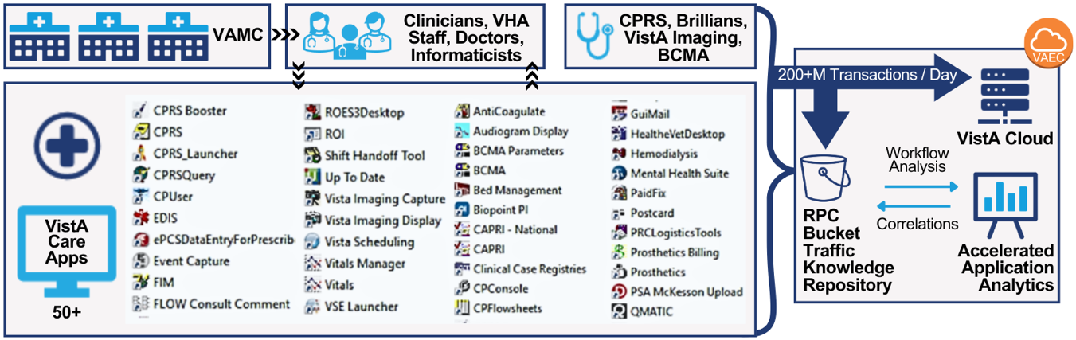

**Figure** **4. Team VetsEZ’s Conceptual Visualization of VistA Care Application Analytics Implementation**

With over 115 million Veteran care encounters provided through VistA point-of-care applications in FY22, our solution fills a crucial gap by measuring and understanding these previously unmeasured workflows. By leveraging cloud-based services, VetsEZ’s VA2 identifies areas for optimization in user experience and efficiency, leading to data-driven improvements in clinical processes. This approach allows us to standardize clinical workflows enterprise-wide, optimize efficiency, and implement a unified method for managing and measuring core clinical and support processes. Our focus on reducing cognitive burden, stabilizing front-line and behind-the-scenes processes, and providing actionable recommendations for improvement areas ensures that Veterans receive world-class healthcare consistently across all VA facilities. Team VetsEZ’s solution enhances clinical staff efficiency and prioritizes the standardization and optimization of clinical workflows, ultimately improving Veteran access to care and supporting the delivery of exceptional healthcare services.

The RPC interfaces of VistA represent one of the most complex and mission-critical systems within the VA, connecting all 130 VistA instances to remote desktop clients and applications. This connectivity enables healthcare providers, clinicians, and administrators to access VistA’s full clinical and non-clinical functionalities. User and client delineate the traffic and logs generated by these RPC interfaces, remain unencrypted, are human-readable, and provide detailed information sufficient for comprehensive analysis, including identifying distinct users and their roles without additional context. VistA Client Traffic Capture entails a) gathering data and b) correlating the RPCs that are instantiated when a user clicks on tabs and form(s) element(s) within CPRS and other VistA Application Clients.

Team VetsEZ will establish a **Clinical Workflow Analytics Framework** that will non-invasively capture a medical center's RPC traffic, aggregate raw streams of RPC data into S3, normalize data into query-able formats to generate detailed reports on that traffic, correlate clinical workflows to the captured traffic, and recommend improvements in clinical workflows based on those correlations. We propose leveraging VAEC cloud-native VA-sanctioned FedRAMP High (GovCloud) AWS services within VAEC, as depicted in Figure 5 below.

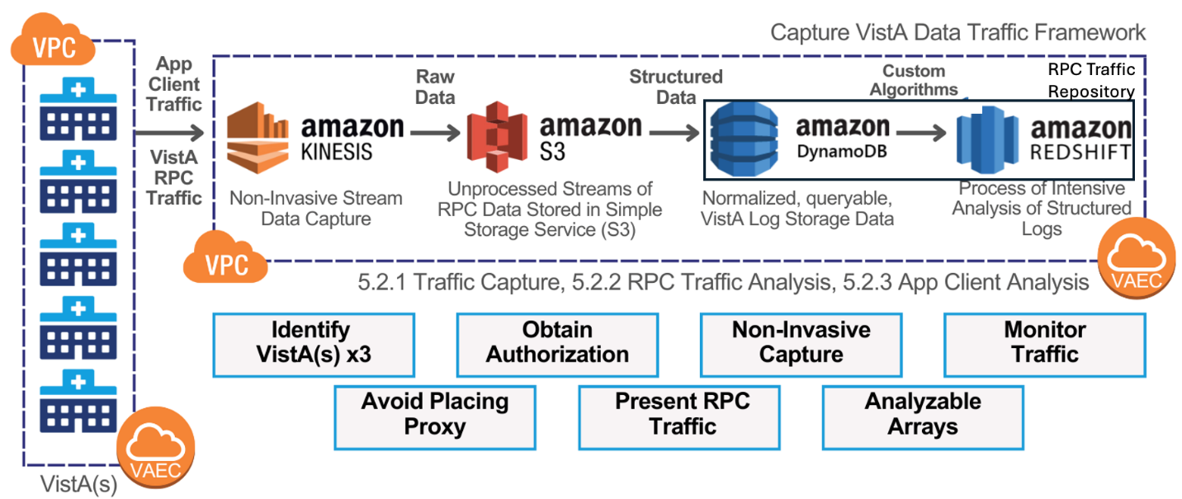

**Figure** **5. Team VetsEZ’s Non-Invasive RPC Traffic Capture and Analysis Framework**

Our solution utilizes VAEC GSS cloud-native services, including streaming services such as Kinesis and storage and analytics services, such as S3, DynamoDB, and Redshift. By using these VAEC cloud-native services, we ensure that our solution fully complies with VA security and privacy requirements while scaling efficiently and cost-effectively to meet varying demands, all while eliminating development and minimizing maintenance needs. This enables us to focus on configuring cloud-capture services and provide a robust, secure, and scalable solution that leverages the VAEC environment, ensuring continuous, non-invasive capture and analysis of RPC-based client traffic for any VAEC-resident VistA system.

### Capture of VistA Client Traffic (PWS 5.2.1)

Team VetsEZ will implement a thorough and non-invasive capture of VistA RPC traffic from three strategically selected VAEC-based production VistA systems, as depicted in Figure 3. Using the advanced capabilities of AWS services within VAEC, such as Kinesis, we will ensure that traffic capture is conducted non-invasively without impacting the performance or functionality of the VistA systems or their clients. To accomplish this, Team VetsEZ will implement a structured approach, drawing on our experience from the VAM project, and centered on the following essential steps:

**Identification of VistA Systems:** During the project's initial phase, Team VetsEZ will collaborate closely with VHA stakeholders to identify three VAEC-hosted VistA systems most suitable for traffic capture. The selection process will ensure that the chosen systems are diverse and represent the broader VistA environment. To achieve this, we will prioritize VistA systems based on several criteria, including their size—considering the volume and scope of large, multi-facility systems compared to medium-sized or smaller ones. Also, we will consider the medical specialties offered at each facility. By selecting a diverse and representative set of VistA systems, Team VetsEZ ensures that captured data will provide a comprehensive view of VistA operations, enabling accurate and actionable analysis.

**Permission Coordination:** Upon identifying target VistAs, Team VetsEZ will proactively engage with the respective authorities at each facility and the VAEC team to obtain the necessary permissions required for logging and capturing RPC traffic. This engagement will involve clear communication with key stakeholders to explain the scope and objectives of the traffic capture, address any concerns they may have, and ensure that all activities align with VA's strict regulatory and operational standards. This diligent approach facilitates a smooth and efficient traffic capture process and builds trust and collaboration with facility authorities, paving the way for successful project execution.

**Network Traffic Capture Setup:** We will configure the direct streaming of network traffic from the AWS VPCs hosting VistA instances to Kinesis by enabling VPC Flow Logs and configuring Kinesis as the destination. **Building on the proven success of a similar Kinesis-S3 setup used for capturing VistA traffic during the VAM project**, Team VetsEZ will employ this non-invasive approach to capture all traffic at the network layer, including in multi-gateway VistA configurations, without introducing application-level overhead or additional points of failure. By utilizing Kinesis, we eliminate the need for a proxy between VistA and its clients, ensuring efficient traffic capture without impacting performance while monitoring and logging traffic from the three identified VistAs for at least one month, with all data stored in VAEC AWS services for analysis. Additionally, Kinesis allows for precise control over traffic capture, enabling it to be turned on or off as needed, all without requiring changes to VistA’s code or configuration. This also provides the flexibility to collect additional traffic as needed, allowing for further analysis, such as seasonal trends, without requiring significant changes. Captured RPC/network traffic logs will be processed and securely transferred to cost-effective storage solutions like Amazon S3, **referred to as the *RPC Traffic Knowledge Repository***, ensuring no data is lost. The logs will be organized by connection and VistA instance, creating raw data streams for further processing. Once captured, this data will be enriched and harmonized using DynamoDB and Redshift into our RPC Traffic Knowledge Repository to provide valuable insights for decision-making.

**Quality Assurance and Validation:** We will validate the traffic capture mechanism using a pre-existing VAEC-based Test VistA before initiating full-scale production capture. This validation involves three key activities to ensure the log capture mechanism's effectiveness.

* First, we will monitor RPC traffic generated using VistA clinical and non-clinical clients, capturing this data in S3 and DynamoDB. This step will verify that typical client interactions with VistA are accurately recorded and stored, confirming the mechanism’s ability to handle routine traffic.
* Next, we will use an open-source RPC Interface Testing Tool to send a variety of RPCs to the Test VistA and validate that S3 and DynamoDB correctly capture these interactions. We will verify that the corresponding logs in S3 and DynamoDB accurately reflect the RPCs sent, ensuring that the traffic capture mechanism can handle a wide range of traffic scenarios.
* Finally, we will assess the system’s robustness by evaluating the transfer from unstructured S3 data to structured DynamoDB. If Kinesis fails to fully stream the interface activity or S3 does not capture all the data, the incomplete dataset will result in errors during this transfer. This serves as a built-in validation, ensuring that each stage of the process checks the effectiveness of the previous one, thereby reinforcing the overall reliability of the traffic capture mechanism.

Our validation process includes monitoring routine client activity and stress-testing with high-volume RPCs to ensure thorough capture and secure storage of all data. Team VetsEZ is dedicated to maintaining rigorous quality assurance throughout the project, implementing regular audits of captured data, automated checks on RPC sequences, and ongoing monitoring to quickly identify and resolve any issues. **This proactive approach ensures that our solution consistently meets, and even surpasses, VA’s standards for reliability and precision. This ensures that the traffic capture mechanism is fully functional and capable of handling the production environment's complexities.** The captured data will be subjected to incremental analysis, beginning with basic queries such as connection volumes, RPC performance, and traffic patterns. As the analysis progresses, higher-level insights, including user identities and roles, will be refined and enriched to provide a more detailed understanding of the captured traffic. This thorough validation and incremental analysis mitigate risks and ensure the final analysis is accurate and reflects real-world conditions, leading to more reliable and meaningful insights. Following these steps will ensure a seamless and precise VistA RPC traffic capture that enhances VA's ability to analyze VistA traffic effectively.

We will develop and deliver a comprehensive ***VistA Traffic Logging Standard Operating Procedure (SOP) (PWS 5.2.1.A)*** that establishes a consistent and repeatable approach to traffic monitoring within VAEC-based VistA systems. This guide will detail a systematic methodology for monitoring, ensuring all activities align with VA’s operational standards and best practices. It will include procedures for obtaining necessary permissions from relevant authorities and guidelines for selecting the most appropriate VistA instances to capture representative traffic data. The guide will also cover the configuration of key VAEC services, such as Kinesis, S3, DynamoDB, and Redshift, ensuring smooth integration and effective operation of VA2. Furthermore, it will provide detailed, step-by-step instructions for capturing and analyzing RPC traffic, offering the VA a robust framework for ongoing traffic analysis. It will also address capacity planning for storage solutions and outline quality assurance measures to ensure the effectiveness of the traffic capture process. The SOP will be made available in multiple formats—Markdown, Microsoft Word, and PDF—and stored in the VA Enterprise GitHub repository for continuous updates.

### Analysis of VistA Client Traffic (PWS 5.2.2)

Leveraging the client traffic logs captured and maintained in the RPC Traffic Knowledge Repository (as detailed in **Section 3.1.1**), we will employ a multi-faceted approach to analysis, enriching the data by uncovering deeper trends and correlations. This comprehensive analysis will include simple queries for foundational metrics, RPC type-based filtered queries for detailed insights, and Longest Common Subsequence (LCS) reduction to identify common patterns in RPC sequences. The RPC traffic measurement and analysis are a crucial milestone in our process, not an end goal. This step enriches our RPC Traffic Knowledge Repository, preparing it for the following complex workflow analysis. While we generate metrics and counts, these are primarily used to validate the enhancement of our data. The true value lies in the enriched repository, which becomes a powerful resource for in-depth workflow analysis, ultimately leading to actionable insights for improving VistA clinical processes. These analysis techniques, carefully selected to address the unique characteristics of VistA traffic data, are designed to extract actionable insights **A picture containing text, first-aid kit, clipart
**from complex traffic log datasets. **Building upon the proven methodologies employed during the VAM project by teaming partner HRG, these techniques ensure robust and reliable analysis.** The following sections detail the specific approaches we will apply for VA2 to achieve comprehensive and accurate results:

**Simple Data Analysis:** To aggregate foundational metrics on VistA traffic—such as traffic volume and RPC usage frequency—we will employ **simple data queries** executed directly on the data stored in S3 to efficiently extract high-level traffic metrics crucial for understanding overall system load and usage patterns. Our approach goes beyond simple traffic metrics. We validate and organize the captured RPC traffic for comprehensive clinical workflow analysis. While traffic load is considered, our primary emphasis is workflow correlation - mapping the relationships between user actions, system responses, and data flows. This correlation is key to understanding and optimizing the complex interactions within VistA, providing a foundation for meaningful improvements in clinical workflows.

**Filtered Data Analysis:** In addition to these foundational metrics, we will also analyze client types and user-specific data, such as user volume and categories. To ensure accurate capture and analysis of this information, relevant data points from specific RPCs listed in Table 2 will be filtered, extracted, and systematically organized into a structured format within DynamoDB as part of the RPC Traffic Knowledge Repository.

**Table** **2. RPC Traffic Analysis – Grouped by RPC Name, RPC Type, and Traffic Attributes**

| **RPC Name** | **RPC Type** | **Data Attributes Within the RPC** |
| --- | --- | --- |
| RPC: TCPConnect | Connection Setup | Contains the IP Address of the client. |
| RPC: XUS SIGN ON SETUP | Authentication | Provides user-identifying content for CAPRI (low security) login and BSE (token-based) login. |
| RPC: XUS AV CODE | Authentication | Holds the user's unique identifier within VistA based on Access-Verify login credentials. |
| RPC: XUS ESSO VALIDATE | Authentication | Captures the client type, user’s unique identifier in VistA, user’s name, and other related identifiers based on PIV card login. |
| RPC: XWB CREATE CONTEXT | Authentication | Identifies specific client types through context, determining the RPCs a client will utilize |
| RPC: XUS GET USER INFO | User Description | Retrieves user demographics, including the user’s unique identifier in VistA, along with the user’s name, title, and service information. |
| RPC: ORWU USERINFO | User Description | Contains the user’s unique identifier in VistA, the user’s name, physician status, and preferences related to CPRS and other systems. |
| RPC: MAGGUSER2 | User Description | Includes the user’s unique identifier in VistA and the user’s name, specifically for Imaging Clients. |

This organized data will provide the foundation for generating detailed insights into user behavior and system usage patterns. **We will utilize reusable RPC Extraction scripts to streamline and standardize the extraction process.** These scripts are designed for efficiency and adaptability, ensuring consistent data extraction across multiple VistA instances. By automating this critical aspect of the analysis, we significantly reduce the risk of human error, ensuring uniform data processing and enhancing the reliability and validity of the final reports.

**RPC Sequence Analysis:** To group RPCs effectively, Team VetsEZ will apply the Longest Common Subsequence (LCS) reduction to isolate frequently occurring RPC sequences—a process termed “RPC Sequence Reduction.” This analysis involves leveraging AWS Redshift for intense log analysis by copying the relevant data from S3 to AWS Redshift, as depicted in Figure 4, where the reductions will occur. The sequences identified through this process will reflect the traffic generated by screens and dialogs frequently used by clinicians. The most observed sequences will align with the most frequently executed tasks, offering valuable insights into clinical workflows.

By applying these analysis methods, Team VetsEZ will create data extraction scripts to automate and gather essential metrics outlined in Table 3, providing a comprehensive understanding of VistA traffic patterns, user behaviors, and overall system performance.

Table 3. VistA Traffic Metric by Analysis Type and Data Representation

|  |  |  |
| --- | --- | --- |
| **Traffic Metric** | **Analysis Type** | **Data Representation** |
| User volume (PWS 5.2.2.a) | Filtered Data Analysis | Unique user identifiers and types from the User Description RPCs traffic will be used to analyze user volume for each VistA. |
| Client types and volume of use (PWS 5.2.2.b) | Filtered Data Analysis | Client types, calling IPs of connections, and user identifiers for machine users will be identified through the Authentication RPC traffic log. |
| Connection volumes, frequency, and duration (PWS 5.2.2.c) | Simple Data Analysis | Every connection, including timestamps for when connections open and close, is logged in the Traffic Log. |
| Types of user authentication/ security and relative use (PWS 5.2.2.d) | Filtered Data Analysis | Traffic Capture Log for Authentication RPCs record the type of user authentication and the associated NIST levels of assurance (LOAs). |
| Machine from end Users (PWS 5.2.2.e) | Filtered Data Analysis | Traffic capture logs machine user logins, and logs connections from specific IP pools. |
| RPC usage frequency and execution times (PWS 5.2.2.f) | Simple Data Analysis | RPC names and invocation start and end times are recorded for each connection in the traffic log. |
| RPC groupings - representing transactions (PWS 5.2.2.g) | RPC Sequence Analysis | Repeated RPC sequences are identified through LCS analysis to isolate frequently appearing sequences in the traffic log. |
| RPCs specific to a VistA from cross-VistA RPCs (PWS 5.2.2.h) | Simple Data Analysis | Instance-specific data representation. Organized by VistA, with RPCs identified by name. |

Data collected and represented will provide a tailored view of each VistA instance's unique RPC patterns and usage. This analysis distinguishes instance-specific RPCs from cross-VistA RPCs, offering insights into local customizations and configurations specific to each VistA deployment; variations in clinical workflow implementations across different facilities, frequency, and patterns of RPC calls unique to each instance; and potential optimization opportunities based on instance-specific usage patterns and comparative analysis between different VistA instances to identify best practices. Team VetsEZ will incorporate Behavioral and Human-Centered Design (HCD) principles from the outset to ensure that the reports are not only technically precise but also accessible and relevant to clinicians and other VA stakeholders. By prioritizing the stakeholders’ needs, we create workflow-improved reports that are intuitive, actionable, and directly contribute to enhancing clinician workflow/applications. **We will automate the generation** **of** ***Traffic Analysis Reports for three production VistAs (PWS 5.2.2.A)***. Additionally, a comprehensive ***Cross VistA Traffic Analysis Report (PWS 5.2.2.B)*** will be produced, identifying unique and shared traffic patterns across the environments. This automated approach not only formalizes and accelerates the analysis process but also facilitates the application of insights gained from later VistAs to earlier ones, thereby **enhancing both the quality and efficiency of subsequent analyses**. These reports will be systematically delivered in multiple formats—Markdown for GitHub, Microsoft Word, and PDF—to accommodate diverse stakeholder needs. All reports will be version-controlled within the VA Enterprise GitHub repository to ensure continuous improvement and consistency. This streamlined, iterative approach will contribute to ongoing optimization, fostering a robust and adaptive analysis framework.

### Analysis of Use of Key VistA Clients (PWS 5.2.3)

The core focus of our approach is to leverage the comprehensive RPC traffic capture to establish **meaningful correlations between clinical workflows and RPC sequences**. Once we have collected and organized all RPC traffic, we map these technical interactions to their corresponding clinical processes. This correlation allows us to understand how specific user actions and clinical decisions translate into RPC calls, providing a clear picture of the relationship between front-end workflows and back-end system operations. **Based on analysis of the users, frequency of use, and performance of the traffic, we then know how often a workflow is used, who uses it, and whether it has performance issues.** By linking these elements, we create a foundation for in-depth analysis of clinical workflows, **enabling us to identify inefficiencies, optimize processes, and enhance overall system performance** in ways that directly impact clinical care delivery.

Using the analysis methods and traffic metrics described in **Section 3.1.2***,* Team VetsEZ will implement an accelerated approach to analyzing key clinical workflows in VistA clients, focusing on critical applications such as CPRS. For example, we will **reuse the established analysis methods and data extraction scripts for key metrics** such as User Volumes and types and Type of user authentication/security and relative use to replicate the VistA-wide analysis per-client basis. **This allows us to efficiently apply proven techniques to individual clients** like CPRS, ensuring that the analysis is thorough and tailored to the specific needs of each application. In addition, we will expand the analysis with additional data extraction scripts, gather essential metrics, as outlined in Table 4, and provide a comprehensive understanding of traffic patterns for key VistA clients.

**Table** **4. Client Traffic Metrics by Analysis Type and Data Representation**

| **Traffic Metric** | **Analysis Type** | **Data Representation** |
| --- | --- | --- |
| User volume and types (PWS 5.2.3.a) | Filtered Data Analysis | User volume for each key client will be analyzed by leveraging unique user identifiers and types extracted from the RPC traffic repository of User Description RPCs using scripts previously developed for **Table 3: User Volume**. |
| Connection volumes, frequency, and duration  (PWS 5.2.3.b) | Simple Data Analysis | Each Client’s connections, including the opening and closing timestamps, are thoroughly analyzed through RPC traffic repository, employing scripts created for **Table 3: Connection volumes**, frequency, and duration. |
| Types of user authentication/ security and relative use (PWS 5.2.3.c) | Filtered Data Analysis | Traffic Capture logs for Authentication RPCs (RPC: XUS SIGNON SETUP, RPC: XUS ESSO VALIDATE) record the client type, user auth type, and associated NIST Level of Assurance. It will be extracted by reusing scripts created for **Table 3: Types of user authentication/security and use**. |
| Patient volumes (PWS 5.2.3.d) | Filtered Data Analysis | Data from Patient Selection RPCs ("ORWPT SELECT," "GMV PTSELECT," and "DGWPT SELECT") will be used to count distinct patient id or DFNs within the connections of each client type. |
| Enumeration of all RPCs used by a client and their relative use (PWS 5.2.3.e) | Filtered Data Analysis | Count and enumerate all RPCs used by each client, counting their frequency of use by reusing scripts from **Table 3: RPC Usage Frequency**. |
| Distinction of clinical from non-clinical RPCs (PWS 5.2.3.f) | Simple Data Analysis | RPC traffic repository will be queried to determine the RPC type, check for the presence of DFNs, and distinguish between clinical and non-clinical RPCs. |
| Distinction of RPCs that change (write) from those that read the clinical record (PWS 5.2.3.g) | Filtered Data Analysis | RPC traffic repository will be queried to determine the RPC type, signatures, and associated parameters. Identifying change RPCs and categorizing them by type requires detailed analysis following a basic heuristic to correct any inaccuracies. This will produce a detailed list and count of change (write) RPCs, categorized by subtype, along with a separate list of non-change (read) RPCs. |
| Distinction of slow running, high overhead, and variable overhead RPCs (PWS 5.2.3.h) | Filtered Data Analysis | The basic traffic representation, including connection volumes, frequency, and duration, reflects the performance of each RPC invocation. This data will isolate RPCs with high and variable overhead, enabling targeted analysis and optimization. |

To achieve a comprehensive understanding of clinical workflows, it is crucial to merge traffic log metrics with a detailed journey map of the application, analyzing each screen and the associated traffic they generate. One of the key challenges in this process is addressing the “Correlation Problem”—determining which traffic corresponds to specific screens and actions within the VistA clients. To address this, we will map screens to their corresponding RPCs, RPC sequence, and RPC performance metrics, and create as well as maintain a Three-Part Task-Set Description (Screen/workflow, RPC sequence, and the associated traffic metrics) for clinical workflows, as shown in Figure 6.

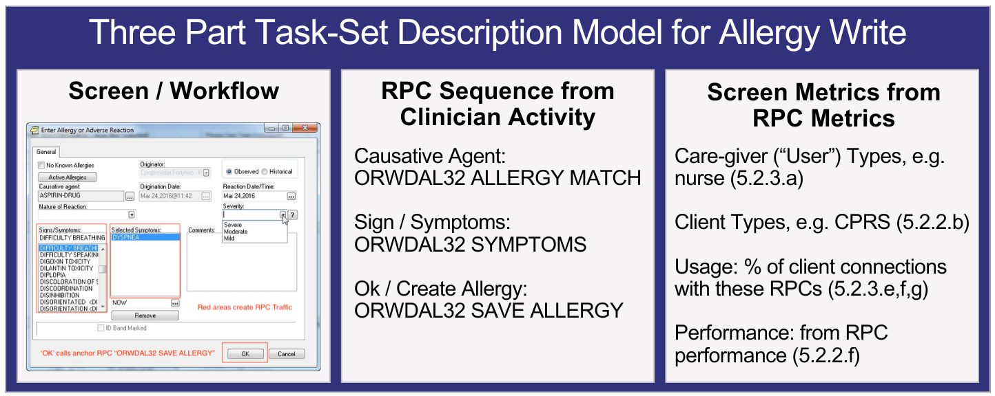

Figure 6. Team VetsEZ’s Proposed Three-Part Task-Set Description Example Model to Enter Allergy

The example captures the task-set description of a clinician using CPRS within the screen for entering allergies or adverse reactions. The elements in the form include known allergies, causative agent, origination date, reaction date, severity, and signs/symptoms (among others). In the screen capture, the highlighted (red) areas and signs/symptoms create RPC traffic; selecting the “OK” button calls anchor RPC ORWDAL32 to save allergy. We start correlating the RPC sequence triggered by clinician activity in CPRS and capturing screen-detailed metrics, as depicted in Figure 6. We use Value Stream mapping methodologies to capture clinicians’ actions in CPRS. In our example, a clinician uses the CPRS “Enter Allergy or Adverse Reaction” dialog to add an allergy to the patient’s medical record in VistA. Using this screen, the clinician chooses a “causative agent” and “sign/symptoms” and finally presses “OK.” Each of these actions leads to RPC traffic; collectively, this traffic makes up an RPC sequence. If this sequence is in CPRS traffic, a clinician has used this screen (screen to RPC sequence correlation). The metrics for this RPC sequence – its frequency of use, what type of clinician used it, and its performance – give us metrics for the equivalent screen (screen metrics) – How often the screen is used, who uses that screen, and whether that screen is performant. Using metrics of all the screens of CPRS and other clients, we will recommend improvements in clinician workflow.

Using Three-Part Task-Set Descriptions, Team VetsEZ will precisely understand how specific user actions within the VistA clients correspond to the underlying RPC traffic, ensuring a clear linkage between clinical workflows and their associated system interactions. For instance, to reuse existing RPCs used by the TeleReader client for Cerner, Team VetsEZ analyzed (as part of our tasks in the Vista Maintenance contract) the “active consult” RPCs used by TeleReader and developed a Three-Step Task Set Description (example depicted in Figure 6). This enabled us to identify the RPCs, map the RPC sequence, and analyze the traffic metrics, **ultimately ensuring a smooth transition and successful implementation**. By accurately mapping screens and actions to their corresponding RPC calls and traffic attributes, we will also easily **identify performance bottlenecks, provide recommendations, and** **optimize frequently used functions, tailoring VistA clients like CPRS to better meet clinician needs**.

These Task-set descriptions will be consolidated in the Comprehensive Task-Set Alignment Report for all three VistA clients/applications, including CPRS. This will empower Team VetsEZ to produce comprehensive Task-Set Descriptions that accurately reflect real-world usage of VistA clients and provide an actionable framework for understanding and optimizing system workflows.

Producing Task-Set descriptions requires more than just traffic capture and analysis; it also calls for additional information from various sources. To accomplish this, Team VetsEZ will utilize relevant manuals from the VistA Document Library (VDL), particularly those for RPC-based clients, to describe the workflows behind the traffic data. These manuals provide crucial content for the clinical workflow component of Task-Set descriptions. For instance, several CPRS manuals, including screenshots and detailed procedures for tasks such as adding a new problem to a patient’s record. To produce the workflow of Task-Set descriptions, Team VetsEZ will conduct VDL reduction as outlined below:

* **Download VDL Guides**: We will retrieve the VDL guides for the clients being analyzed.
* **Isolate and Index Workflows**: Workflows, their corresponding screenshots, and procedure descriptions will be isolated and indexed for easy reference.
* **Reduce Key Procedures to Flowcharts**: Key procedures will be simplified into flowcharts. Since the reports will be in Markdown, we will use Mermaid markup to create these flowcharts for seamless integration.

For example, CPRS, the key clinical client for VA clinicians, has evolved to support a broader range of clinical users while keeping pace with advancements in medical practice. Responsible for approximately three-quarters of RPC traffic through the RPC Interface, CPRS is the largest and most intricate VistA client. It includes a comprehensive Technical and User Guide, along with specialized manuals for complex functions like consult ordering and template notes, all enhanced with detailed screenshots and step-by-step instructions reveal that CPRS is organized into ten tabs, each functioning as a “sub-client” (e.g., Coversheet, Problem, Medications). Within the subsections of various manuals, we encounter task-specific dialogs. For example, the VDL specifies that the Coversheet allows a clinician to enter an allergy. To do so, the clinician selects a “causative agent,” identifies “signs/symptoms,” and presses “OK.” Each of these actions generates RPC traffic. A VDL-derived clinical workflow description for this task will capture both the pathway to the dialog and the actions performed within the dialog. We will develop scripts to download and parse the CPRS manuals to capture these workflows, extracting workflow descriptions based on screenshots. This approach will ensure our analysis reflects the structure and capabilities outlined in the CPRS VDL manuals. The exact process will be applied to the other two point-of-care clients under analysis. Using RPC Sequence Analysis from **Section 3.1.2**, Team VetsEZ will first identify the RPC sequences present in the traffic. Simultaneously, from the VDL-derived Clinical Workflow Description outlined above, we will have a comprehensive set of screenshot-backed Clinical Workflow Descriptions. To align these two distinct data sets and produce accurate Task-Set Descriptions, we will undertake a process known as Clinical Workflow Correlation (“Correlation”), depicted in Figure 7. The steps involved in this Correlation process are as follows:

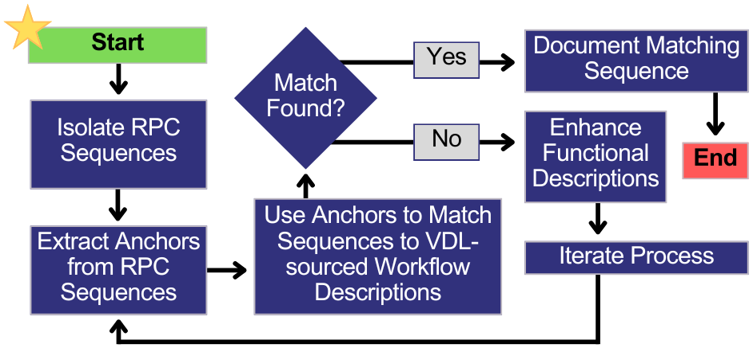

**Figure** **7. RPC Clinical Workflow Correlation Process**

* **Link VDL-Derived Clinical Workflow Descriptions to RPC Sequences:** We will systematically link the VDL-derived clinical workflow descriptions to the corresponding RPC sequences observed in a client's traffic. This ensures that each clinical task is accurately associated with its underlying RPC activities.
* **Derive New Task-Sets for Uncovered RPC Sequences:** We will derive new task-sets for RPC sequences that appear in the traffic but are not covered in the VDL manuals. This step ensures that all observed RPC activities are accounted for, even those not explicitly documented in the manuals.
* **Identify VDL-Derived Workflows without Corresponding RPC Sequences:** We will identify any clinical workflows from the VDL that do not have corresponding RPC sequences in the traffic data. This will help us understand potential gaps or unused functionalities within the client environment.
* **Identify Anchor RPCs:** We will identify a subset of RPCs, referred to as “anchors”, representing a workflow's key actions. These anchor RPCs are crucial because they are the primary indicators of the workflow's execution within the traffic data.

Using this well-defined process, we will iteratively correlate the RPC sequences isolated in **Section 3.1.2** with VDL-sourced workflow descriptions, ensuring a precise alignment between the documented clinical workflows and the actual RPC traffic.

Upon completion of this analysis, our Functional Area SMEs, will develop and maintain Three-Part Task-Set Descriptions by correlating screen-backed workflows, RPC sequences derived from traffic, and RPC traffic attributes using a Comprehensive Task-Set Alignment Report for all three most used VistA point-of-care applications, including CPRS. Additionally, this correlation process will reveal different methods for performing the same function by **identifying equivalent task sets, such as screens or pathways that generate identical traffic patterns, thereby streamlining workflow analysis and optimization**. For unmatched VDL-sourced workflow descriptions and RPC sequences, Team VetsEZ will collaborate with users to understand how these undocumented activities were created and document these cases, providing a more complete and accurate representation of the system's use.

Team VetsEZ will **accelerate per-client traffic analysis to meet the following requirements using the results of the traffic log analysis from** Table 4 **and the Three-Part Task-Set Descriptions in the Comprehensive Task-Set Alignment Report**, as detailed below:

**Table** **5. VistA Client Workflow Analysis using Task-Set Descriptions**

| **Requirement** | **Analysis Approach** |
| --- | --- |
| Clinical care task sets, represented as groups of RPCs used in tandem (PWS 5.2.3.i) | RPC sequences in Three-Part Task-Set Descriptions relevant to clinical care will be leveraged to understand how RPCs are used in tandem. |
| Match task sets with the use of one or more specific client screens (PWS 5.2.3.j) | Three-Part Task-Set Descriptions in the Task-Set Alignment Report align task sets with client screens. |
| Task sets employed by different user types (PWS 5.2.3.k) | Cross-referencing the User Volume and Types metric from the traffic log analysis in Table 4, with RPC sequences in the Three-Part Task-Set Descriptions, we will categorize task sets by user type, identifying specific workflows and behaviors for each role. |
| Isolate performance issues with patterns of use that slow care (PWS 5.2.3.l) | By aligning the distinction of slow-running, high overhead, and variable overhead RPCs metric from the traffic log analysis in Table 4 with the RPC sequences in the Three-Part Task-Set Descriptions, we will pinpoint performance issues within the RPC sequence of each Task-Set. |

We will consolidate these traffic metrics gathered from the traffic logs, described in Table 4 and Table 5, to create Client Traffic Analysis Reports in Markdown format, which will be uploaded to the VA’s Enterprise GitHub. These reports will be integrated with Task-Set descriptions and Task-Set-based analysis to produce the ***VistA Client Use Analysis Reports*** ***(PWS 5.2.3.A)*** for each VistA client. Following this rigorous and detailed analysis process, Team VetsEZ will correlate RPC sequences with client screens to develop comprehensive Task-Set Descriptions and produce insightful VistA Client Use Analysis Reports, contributing to more efficient and effective care delivery that meets the evolving needs of the VA and its stakeholders.

**Validation and Verification of Care Provision (PWS 5.2.3.m).** To accurately capture care provision, we will employ a rigorous validation and verification process focused on the completeness and correctness of traffic-backed Task-Set Descriptions. This approach ensures that our analysis reflects the true clinical workflows within VistA. To achieve this, we will utilize several verification and validation methods:

* **Task-Set Correlation Verification:** We will verify the accuracy of our Task-Set Descriptions by correlating all RPC sequences with VDL-backed workflows. This correlation process provides a built-in level of verification, where any unmatched RPC sequences or VDL workflows will be immediately flagged for further review.
* **Clinician Survey Validation:** We will engage with a representative sample of clinicians whose activities generated the captured traffic, focusing on confirming our analysis, particularly for Task-Sets linked to performance issues. Additionally, we will reach out to clinicians whose traffic did not align with any VDL-backed workflows to ensure our descriptions accurately reflect real-world usage.
* **Test VistA Validation:** Workflows representing a sample of Task-Sets will be validated using Test VistA. Through traffic capture, we will validate that the resultant traffic matches the RPC sequences identified in Task-Set Descriptions, thereby further confirming the accuracy of our analysis.

Upon completion of these activities, we will produce a comprehensive ***Client Analysis Validation and Verification Report (PWS 5.2.3.B)***that includes:

* A full account of the Task-Set Descriptions and the traffic correlation process.
* Detailed results of user surveys conducted with clinicians.
* Results from Test VistA validations, ensuring the reliability of the Task-Set Descriptions.

This thorough validation and verification process will ensure that our analysis accurately captures care provision and provides a robust framework for ongoing optimization of the VistA system.

### VistA Client Use Improvement Report (PWS 5.2.4)

Using the VistA Client Use Analysis Report detailed in **Section 3.1.3**, which comprehensively catalogs all the Task-Sets for each client, ordered and distinguished by user type, performance, and frequency of use, Team VetsEZ will apply a structured methodology to thoroughly analyze these Task-Sets, as we successfully did for the TeleReader Client. Team VetsEZ has participated in the VistA Adaptive Maintenance contract (RPC traffic capture and measurement), VistA Data Project (select RPC sequences from CPRS were re-used in a new web-based client with the same workflow) contract, and VA TeleReader contract (workflow of VistA client RPC Sequences made to work over Cerner EHR. Our Functional Area SMEs will support the following:

* **RPC Assessments and Comparative Analysis:** We will conduct a comparative analysis across different user types and specialties to identify workflow efficiency and performance variations. By examining how different users interact with the same Task-Sets, we can uncover best practices and identify areas where workflow standardization may be beneficial.
* **Performance Benchmarking:** Task-Sets will be benchmarked against predefined performance metrics to identify those that consistently underperform. This will involve analyzing response times, error rates, and user feedback to determine the root causes of inefficiencies and guide targeted improvements.
* **Frequency of Use Assessment:** We will assess the frequency of use for each Task-Set to determine which workflows are essential and which may be candidates for streamlining or elimination. Low-use Task-Sets may indicate outdated or redundant features contributing to 'UI/UX clutter.'
* **Correlation with Clinical Outcomes:** Where possible, we will correlate specific Task-Sets with clinical outcomes, enabling us to prioritize improvements with the greatest potential to enhance patient care.

This structured approach will enable us to pinpoint inefficiencies, performance bottlenecks, and underutilized workflows. Insights gained from this analysis will form the foundation for developing targeted recommendations to optimize clinical workflows for each VistA client, ensuring alignment with best practices and tailoring solutions to specific user needs. These detailed analyses will be compiled into ***Client Use Improvement Reports (PWS 5.2.4.A)***, tailored to **enhance clinical workflow efficiency and effectiveness**. In the report, we will provide recommendations to optimize the performance and usability of VistA clients, including:

* **Optimal Workflow Identification:** We will identify and recommend the most efficient workflow for tasks that can be executed through multiple methods. Standardizing these activities will streamline operations and reduce variability in clinical practices, ensuring that all users adopt the most effective approach.
* **Reconfigurations for Consistent Performance:** In cases where the same workflow exhibits inconsistent performance across different configurations or user settings, we will propose reconfigurations to harmonize and optimize the workflow’s performance, ensuring all users experience optimal efficiency.
* **Replacement of Inefficient Workflows:** For workflows that consistently underperform or create bottlenecks in clinical operations, we will recommend their replacement with more efficient alternatives. This will involve analyzing the root causes of poor performance and suggesting new workflows that better meet the demands of clinical care.

These recommendations will be broken down by user type and specialty, offering tailored suggestions for different clinical roles. For example, we will provide separate, specialized recommendations for nurses, surgeons, and other key healthcare professionals, ensuring that the proposed improvements align with each role's specific needs and responsibilities.To ensure clarity and accessibility for a diverse audience, including technical and non-technical stakeholders, the recommendations will be documented in ***Client Use Improvement Reports (PWS 5.2.4.A)*** for each client in Microsoft Word and a supporting PowerPoint presentation. Through this comprehensive and methodical approach, Team VetsEZ will deliver actionable insights and targeted recommendations, ensuring that VistA clients are optimized for peak performance and usability, ultimately enhancing the quality of care provided to Veterans.

## Migrated VistA Client Traffic Capture and Analysis (RTEP B.1.1; PWS 5.3)

VistA/CPRS usage is evaluated at transitioned sites to identify functionality that may fully or partially be transitioned to the new OH EHR. Trend analyses and reporting are used to determine when clinical application options are no longer utilized after successful deployment of the EHR at each transition site. Lessons learned from RPC capture and analysis described in **Section 3.1.1** will be leveraged to enhance the Clinician Experience across the continuum of care to provide a unifying, optimized experience for care teams. Findings assist VHA site POCs and VA leadership in making data-driven decisions throughout the EHR transition. Usage includes CPRS usage monitoring, VistA option usage, file growth, HL7 traffic, and TaskMan (scheduled options). The VistA Usage Evaluation Report includes detailed information on the site's usage of CPRS problems, allergies, vitals, orders, consults and notes, HL7 traffic, TaskMan scheduled options, VistA file growth, menu, and protocol usage. Team VetsEZ understands the evolving landscape of VistA functionality in light of the migration to Cerner OH (Oracle Health). Our approach to leveraging our cloud-based **RPC Traffic Analyzer** will account for this transition, focusing on auditing VistAs, which is still in production but operating with a reduced set of functionality. To address the gap between migrated functionality and remaining VistA operations, we propose the following approach:

* **Gap Analysis:** By analyzing data obtained during traffic capture, we can correlate and harmonize it, catalog VistA-phased-out functions, and assess and conduct a thorough review of the functionality migrated to OH. This review will be compared against the current VistA operations to identify the subset of functionality still active in production VistAs.
* **Targeted Traffic Capture and Analysis:** Our RPC traffic capture and analysis will be tailored to focus specifically on the remaining active VistA functionality . This targeted approach ensures that our analyzer remains relevant and efficient in the current hybrid environment.
* **Scalable Analyzer Configurations:** The RPC Traffic Analyzer will be configured with modularity in mind, allowing for easy updates as the VistA landscape continues evolving. A comprehensive set of scripts and configurations will be tailored to analyze the current subset of VistA functionality. These will be packaged to ensure easy deployment and execution within the VAEC.

To validate the comprehensiveness and accuracy of the analyzer––within migrated VistAs––we will reproduce Traffic Analysis Reports for all three Analyzed VistAs using the developed analyzer. This process will be a quality assurance step, ensuring the analyzer's reliability and effectiveness in the current VistA environment. By leveraging our existing knowledge and adapting our approach to the current state of VistA operations, Team VetsEZ will deliver a robust, relevant, and future-proof RPC Traffic Analyzer that meets the VA's evolving needs. Team VetsEZ’s extensive experience with VistA systems and RPCs highlights the feasibility of our technical approaches, reduces VA2 performance risk, and positively impacts clinical workflows, as demonstrated below:

* Team VetsEZ's expertise in VistA systems, gained through projects like VistA Adaptive Maintenance, VistA Data Project, and VA TeleReader, positions us uniquely to enhance clinical workflows and reduce cognitive burden for clinicians. By correlating RPC traffic to VistA client usage, we have consistently improved system efficiency and user experience. Our work on RPC traffic capture and measurement has allowed us to precisely identify bottlenecks and inefficiencies.
* A clock and arrow with a red cross

  Description automatically generatedIn the VistA Data Project, we successfully translated select RPC sequences from CPRS into a web-based client, maintaining familiar workflows while modernizing the interface. Our involvement in VA TeleReader demonstrated our ability to adapt VistA client RPC sequences to work seamlessly over Cerner EHR, showcasing our adaptability across different healthcare IT ecosystems. Now, with VistA point-of-care advanced analytics, we are leveraging this accumulated knowledge to further **streamline processes, providing clinicians with more intuitive, responsive systems that minimize cognitive load and maximize time for patient care**. Our track record proves our capacity to turn complex RPC data into tangible improvements in clinical workflows, ultimately enhancing healthcare delivery for Veterans.

### Migrated VistA Client Traffic Analysis (PWS 5.3.1)

Our approach will capture client traffic from a Migrated VistA over one month using the established mechanism from the base period, as outlined in **Section 3.1.1**. This traffic will feed into an RPC traffic knowledge repository, enabling comprehensive analysis. The resulting ***Migrated VistA Traffic Analysis Report*** (***PWS 5.3.1.A***) will focus on several key deliverables:

* **Identification of Active Clients:** We will determine which clients are still in use and analyze how they are utilized within the Migrated VistA environment.
* **User Type and Volume Analysis:** Our team will assess and categorize the types and volumes of users who continue to operate within this VistA system, providing insights into ongoing usage patterns.
* **RPC Usage Comparison:** We will identify the subset of RPCs still in use and compare this to the range of RPCs utilized in fully operational VistA systems analyzed in the base year. This comparison will highlight any changes in functionality and usage post-migration.

Through these deliverables, Team VetsEZ aims to provide actionable insights into the current state of the Migrated VistA, ensuring that VHA can make informed decisions about future system optimizations and transitions. On April 21, 2023, VA announced that it is halting additional deployments of the new OH/Cerner Millenium until it is confident that the system is highly functioning at current sites and ready to deliver for Veterans and VA clinicians at future sites. This readiness will be demonstrated by measurable improvements in the clinician and Veteran experience, sustained high performance and high reliability of the system, and a return to expected levels of productivity at the sites where the OH is in use. As VA plans to exit the reset and begin pre-deployment activities in FY 2025, it is important to note the list of sites that have deployed the OH as listed below. VHA is investing in Clinical Productivity and Experiences (CPE) pilots to provide VA clinicians with a predictive clinical workflow platform to reduce the time spent in Millennium patient charts, increase patient throughput, and allow clinicians to redirect their time from system interaction to improve care quality. Upon the success of the planned CPE Columbus pilot, a decision will be made to continue future CPE deployment sites in OH migrated VistA sites in Columbus, Spokane, Walla Walla, White City, Roseburg, and North Chicago. We intend to **configure VA2 as the programmatic critical layer that can inform, augment, and enhance CPE across VHA to ease the transitional and cognitive burden and improve clinician productivity and informaticist morale while improving Veteran safety**.

### VistA Community Care Client Traffic Analysis (PWS 5.3.2)

Team VetsEZ currently supports integrating Community Care (CC) data with VistA systems, providing functional, clinical, and workflow automation support in several CC applications. Our Functional Area SMEs, Business Process Experts, and Performance Analyst support several clinical workflows (e.g., eligibility, entitlement, referral, authorization, insurance verification, SEOC, reimbursements, offsets), workstreams, value streams, and journey maps for VA Community Care. We propose a comprehensive technical approach to isolate and capture VistA client traffic related to CC, leveraging the methodology established in the base period (**Section 3.1.1**). This initiative aims to enhance the integration of CC data with VA systems. For context, and relevant to this TEP, it is worth mentioning that VetsEZ currently manages the CC EPSI (Electronic Precision Scanning and Indexing) product. EPSI is an automation tool used to index and store documents received from CC providers. Indexing involves associating the document with the patient and consult that triggered the patient’s consult at the CC provider. This data capture type includes volumes and sources of parseable text, including clinical notes. EPSI includes a storing automation process for sending the document to VistA Imaging and creating an associated Text Integration Utilities (TIU) note to close the consult within CPRS. This capture covers type, volumes, references, and where/how data is displayed in VistA clients. Team VetsEZ also supports the CC Consult Tool Box (CTB). CTB provides a modernized input layer on top of the CPRS or Consult Tracking Manager (CTM+) used to maintain Veteran patient records in VistA. CTB allows clinicians to easily select items for inclusion within VistA Comments. Selections within the CTB are transferred to the comments field by CPRS/CTM+ after retrieving the data from RESTful APIs provided by the CTB application. CTB is designed to improve the business process used by VHA providers and supporting staff. Our approach to enhance the integration of CC data with VistA systems will focus on the following key deliverables:

* **Data Capture and Analysis:** Using time as a dimension, we will capture one month of episodes of care, explanation of care, and coordination of care data, as well as VistA client traffic reflecting CC episodes. This will ensure a thorough collection of data that includes types, volumes, and sources, structured and unstructured payloads of parseable text, and references to images and screenshots.
* **Information Display Assessment:** We will analyze where and how this information is displayed across existing and specialized VistA clients, providing insights into the current data presentation and usage. We will correlate RPC traffic to VistA screens utilizing our framework described in **Section 3.1.1**. The output of our assessment will culminate in the ***PWS 5.3.2.A Vista Community Care Traffic Analysis Report***.
* **Integration Recommendations:** Based on our findings, we will catalog external data, create a dedicated CC data-services listing, and offer recommendations for better integrating external Community Care information with VA's clinical and other data systems, aiming to streamline workflows and enhance data accessibility.

The ultimate outcome of migrated analysis tasks will be a detailed ***PWS 5.3.2.A VistA Community Care Traffic Analysis Report*** will provide actionable insights and strategies for improving the integration and utilization of Community Care data within the VA's healthcare framework. This report will support the VA's ongoing efforts to enhance Veteran care by bridging data from private sector providers with VA's existing systems.

# Project Task Schedule (RTEP B.1.2)

Figure 8 is an overview (conceptual Journey Map and Roadmap) of the VA2 framework timeline. Our support activities align with those of the VHA Office and are completed in close collaboration with the VHA Office of Health Informatics. On top of the timeline are the various RPC traffic activities and critical path tasks that enable VA2 success. 180 days before sites are scheduled for traffic capture and analysis, Team VetsEZ begins coordinating with stakeholders on this timeline of supporting activities, configuring VAEC, S3, and Kinesis, and obtaining permissions for non-invasive CPRS data capture and analysis at selected VistA sites. Note the bar at the bottom, reflecting Team VetsEZ’s expertise and collaboration with VHA, **Health Informatics Transition Team (HITT)** and VistA and VAEC personnel.The critical path is defined by the configuration of the VAEC VA2 cloud-native tools (e.g., Kinesis, S3, Dynamo), RPC traffic and client capture, RPC traffic analyzer, and most importantly, correlation assessments of the captured traffic to the clinical workflow so we can make educated recommendations.

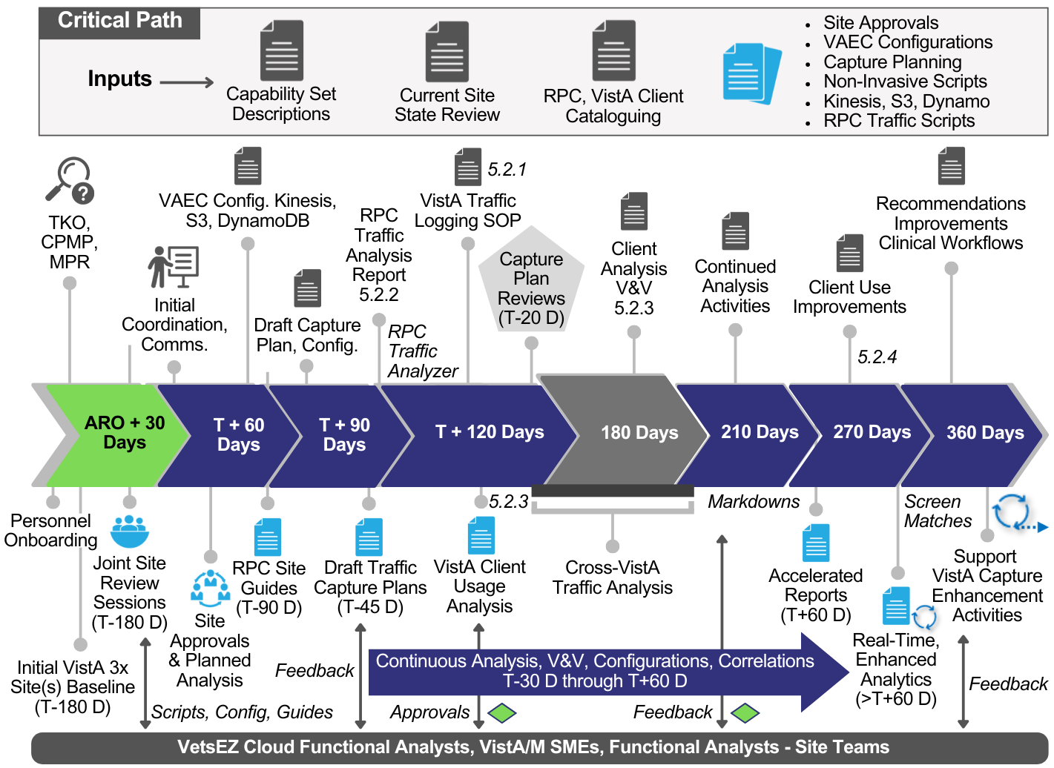

**Figure** **8. Team VetsEZ Follows the VA2 Framework Timeline and Collaborates Closely with the VHA**

Our roadmap converges on a critical outcome: identifying Clinical Workflow/Task-Sets primed for improvement based on quantitative data harmonized in our RPC knowledge repository. In **Section 3.1.3**, we describe how we will correlate VDL documentation with actual workflows, completing this for CPRS within 90 days while simultaneously identifying two additional key analytic clients within 60 days. Our analysis will leverage VistA 1, 2, and 3 data and the Test VistA environment, ensuring a comprehensive and robust evaluation across multiple systems. Per contract requirements (depicted in Table 6 and Figures 8 and **9**), we will deliver the following:

**Table 6. VetsEZ Proposed Deliverable Schedule for Vista Application Analytics**

| **CLIN** | **Deliverable** | **Description** |
| --- | --- | --- |
| 0001AA | Contractor Project Management Plan (CPMP) | In alignment with PWS 5.1.1, delivered 30 days after award |
| 0001AB | Monthly Progress Report (MPR) | In alignment with PWS 5.1.2 delivered monthly on the 5th e/month |
| 0001AC | Vista Traffic Logging SOP | In alignment with PWS 5.2.1 delivered 100 days after award |
| 0001AD | Traffic Analysis Reports for 3 Vistas | In alignment with PWS 5.2.2 delivered 120 days after award |
| 0001AE | Cross-Vista Traffic Analysis Report | In alignment with PWS 5.2.2 delivered 150 days after award |
| 0001AF | VistA (3) Client Usage Report | In alignment with PWS 5.2.3 delivered 150 days after award |
| 0001AG | Client Analysis V&V Report | In alignment with PWS 5.2.3 delivered 150 days after award |
| 0001AH | Client Use Improvement Reports | In alignment with PWS 5.2.4 delivered 240 days after award |

**Team VetsEZ is prepared to deliver at a 20% efficiency rate from the requested ARO requirements stipulated in the price schedule.** Figure 9 is our detailed VA2 Gantt Chart that indicates the expected start and completion dates for all project tasks and sub-tasks.

**Figure** **9. Team VetsEZ VA2 Gantt Chart Details the Complex VA2 Project (C*ontinued on Pgs. 23 and 24)***

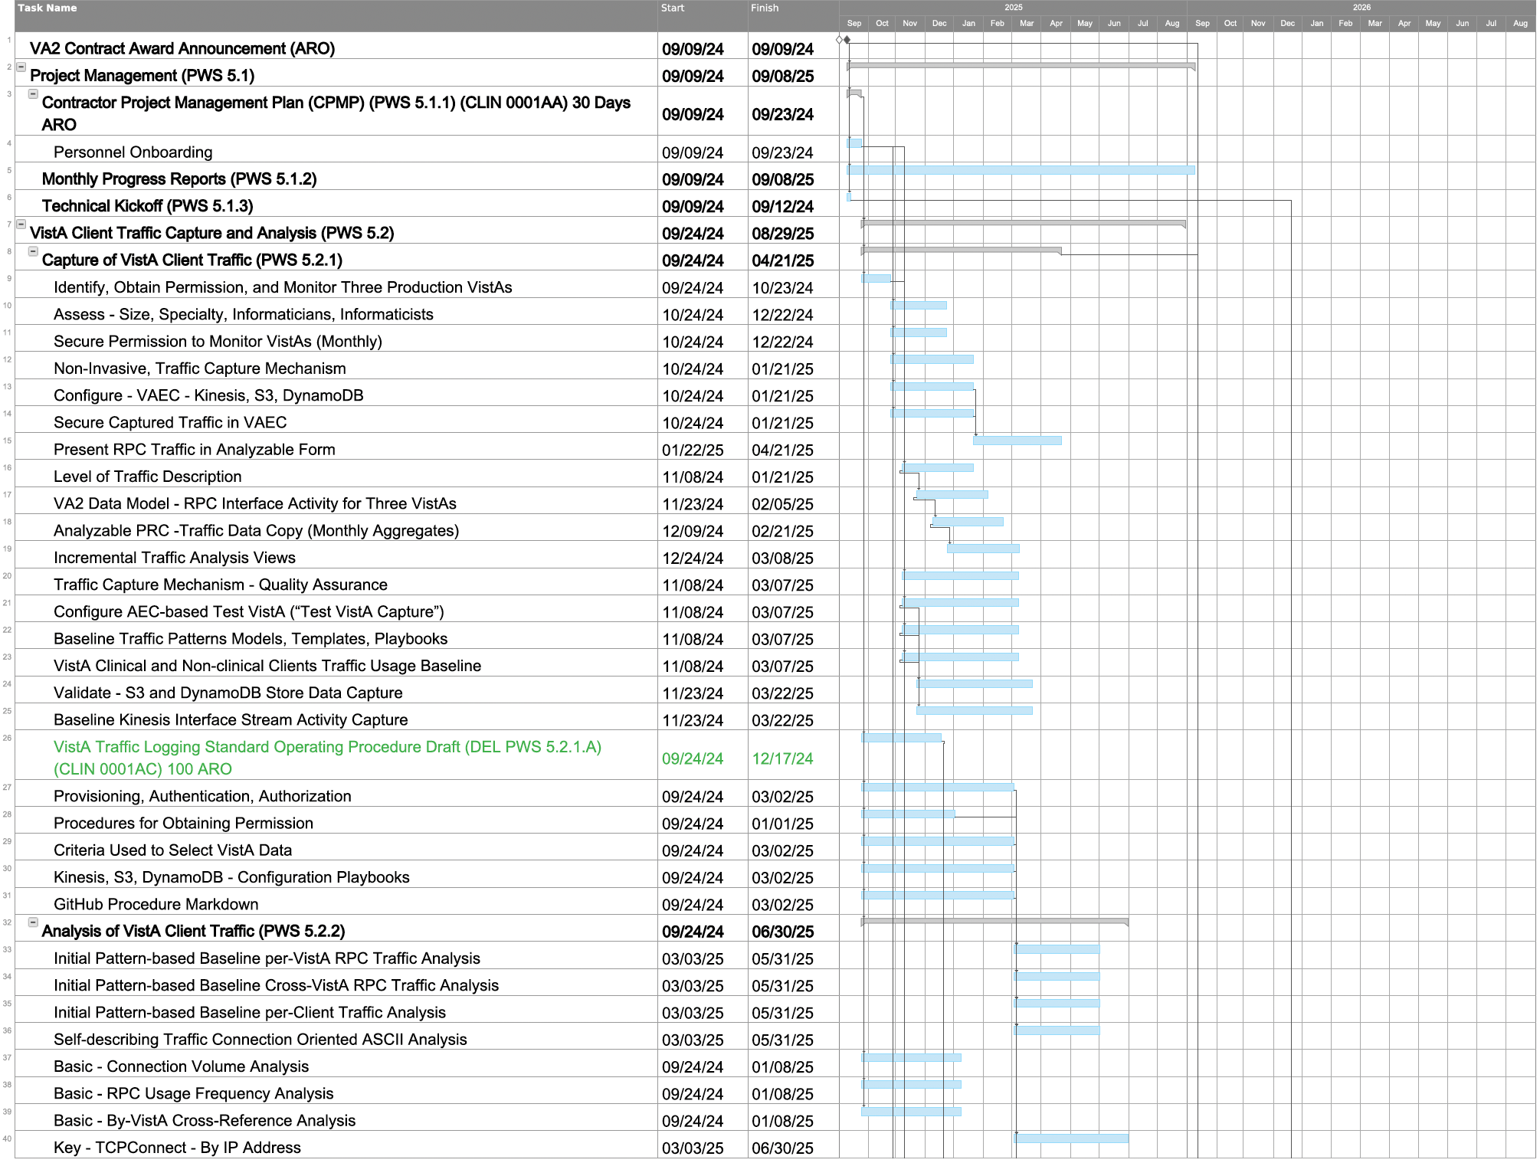

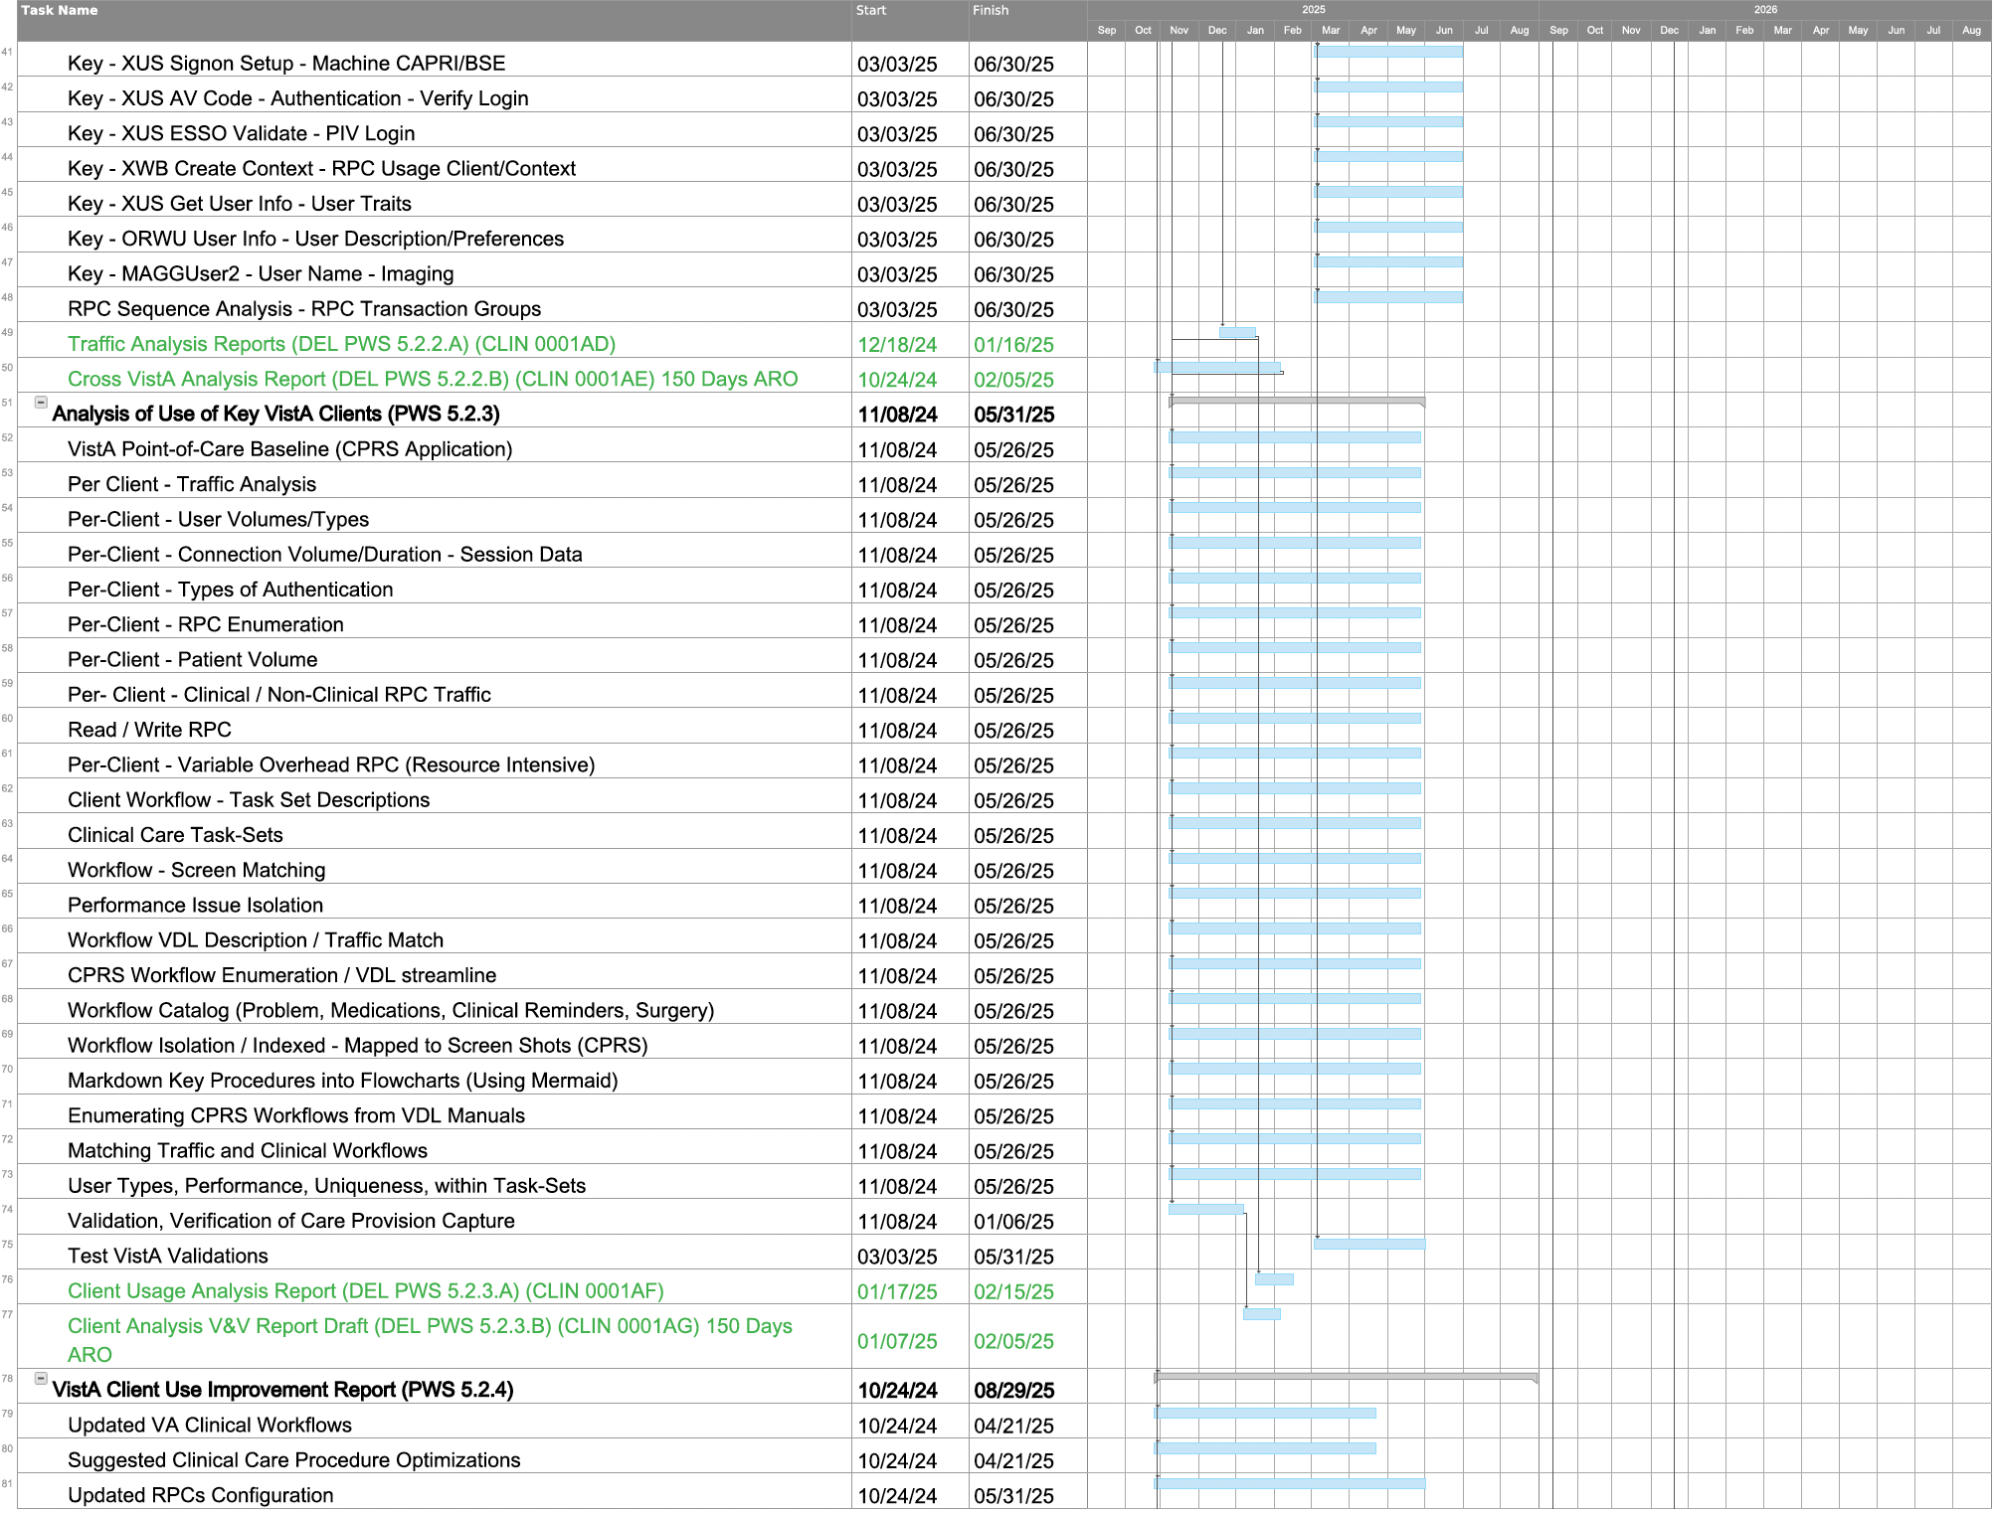

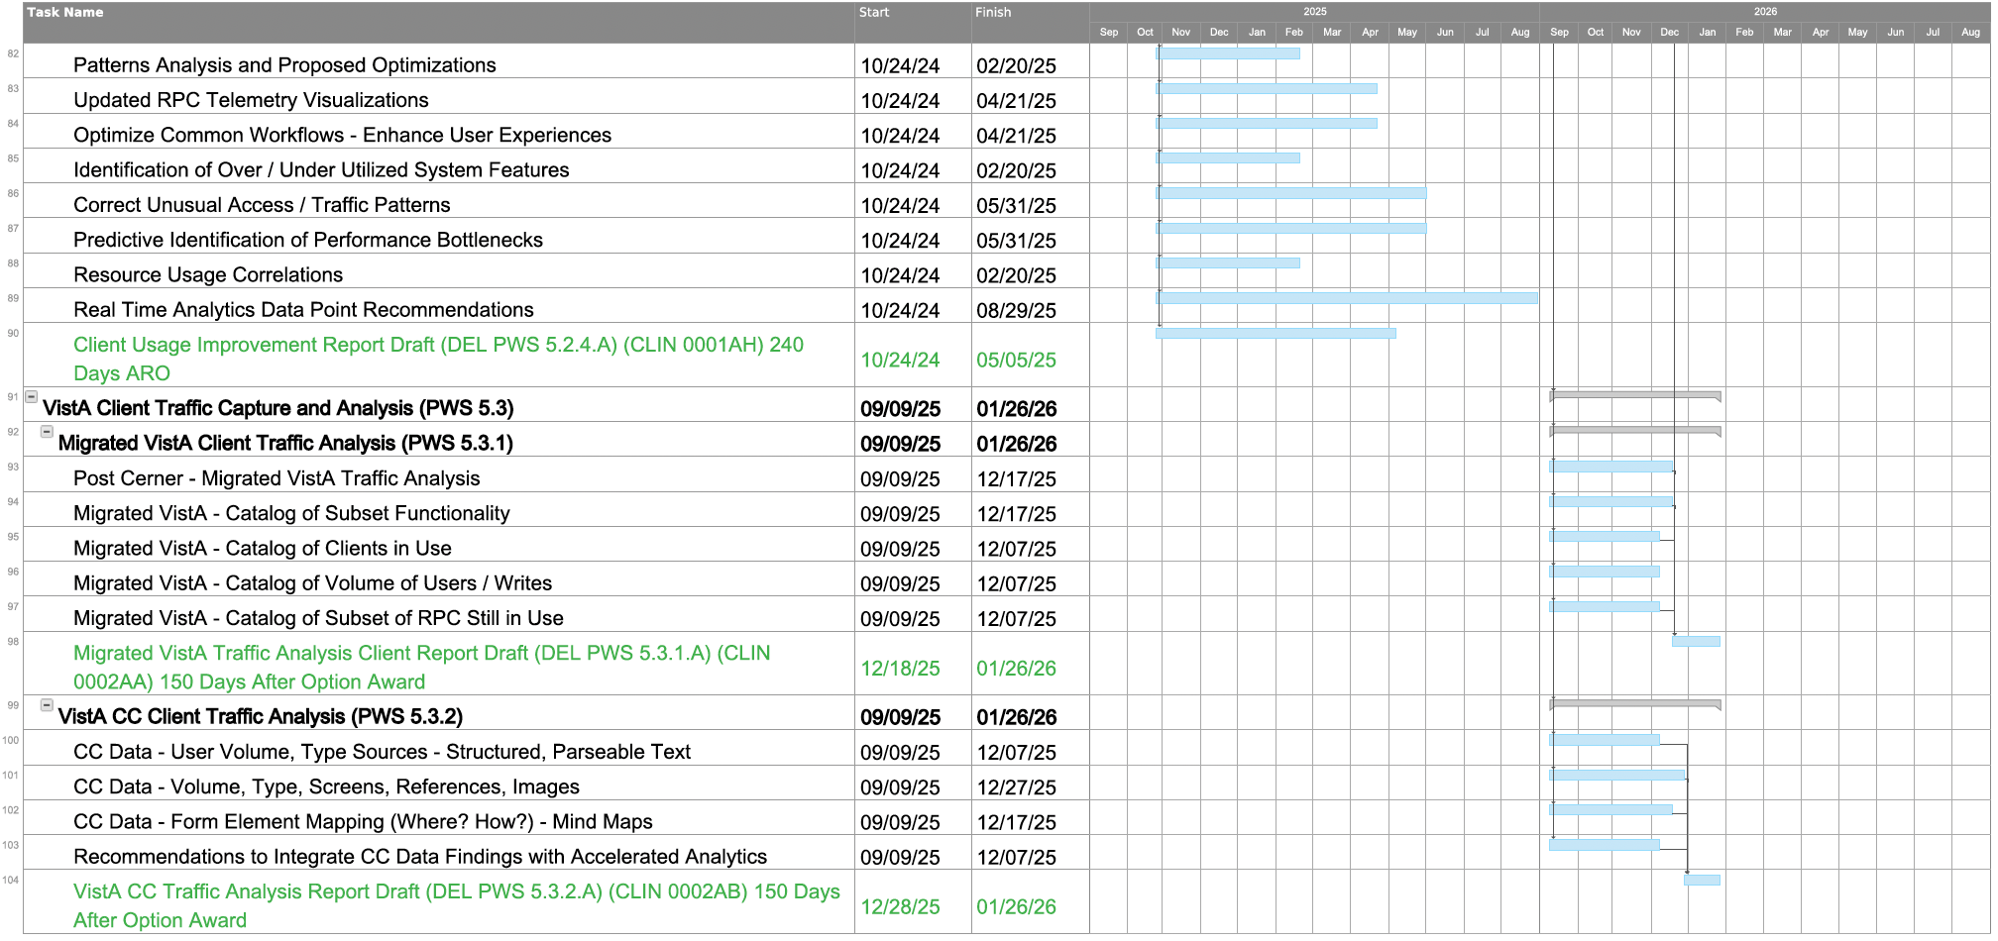

# Level of Effort (RTEP B.1.3)

Team VetsEZ support for VA2 (Table 7 and Table 8) is comprised of a Software/Systems Architect, a seasoned professional with over five years of experience in AWS, and expertise in configuring and managing cloud-based containers and storage solutions with a proven track record in optimizing cloud environments for large-scale data analytics projects. Our RPC SMEs (e.g., Business Process Expert, Business Analysts) have 10+ years of hands-on experience with VA's VistA system and an in-depth knowledge of RPC interface and routines. Our Functional Area Analysts and Data SMEs have over a decade of experience profiling and interpreting VistA's communications and internal operations. They have specialized skills in correlating, identifying, and analyzing complex clinical workflow system interactions within VistA. Our SMEs have the proven ability to translate technical findings into actionable insights for workflow optimizations.

**Table** **7. Team VetsEZ VistA Application Analytics Level of Effort (LOE) for Base Year**

| **LCAT** | **Company** | **Traffic Capture**  **PWS 5.2.1** | **Traffic Analysis**  **PWS 5.2.2** | **Client Analysis**  **PWS 5.2.3** | **Recommendations**  **PWS 5.2.4** | **Total** |
| --- | --- | --- | --- | --- | --- | --- |
| Software/System Architect | VetsEZ | 470 | 470 | 470 | 470 | 1,880 |
| Business Process Expert | HRG | 470 | 470 | 470 | 470 | 1,880 |
| Performance Analyst | VetsEZ | 470 | 470 | 470 | 470 | 1,880 |
| Project Manager | VetsEZ | 470 | 470 | 470 | 470 | 1,880 |
| Functional Area Analyst, Sr | HRG | 235 | 235 | 940 | 235 | 1,645 |
| Business Process Expert | HRG | 235 | 235 | 940 | 235 | 1,645 |
| Data Manager | VetsEZ | 470 | 940 | 235 | 235 | 1,880 |
| Business Analyst, Sr | HRG | 470 | 235 | 940 | 235 | 1,880 |
| Functional Area Expert II | HRG | 470 | 235 | 940 | 235 | 1,880 |
| Database Architect, Sr | VetsEZ | 235 | 940 | 235 | 470 | 1,880 |
| Data Manager | HRG | 235 | 940 | 235 | 470 | 1,880 |
| Database Analyst | VetsEZ | 235 | 940 | 235 | 470 | 1,880 |
| **Total** |  | **4,465** | **6,580** | **6,580** | **4,465** | **22,090** |

**Table** **8. Team VetsEZ VistA Application Analytics Level of Effort (LOE) for Option Year**

|  |  |  |  |  |
| --- | --- | --- | --- | --- |
| **LCAT** | **Company** | **VistA Traffic Analysis**  **PWS 5.3.1** | **CC Traffic Analysis**  **PWS 5.3.2** | **Total** |
| Business Process Expert | VetsEZ | 470 | 470 | 940 |
| Performance Analyst | VetsEZ | 470 | 470 | 940 |
| Business Process Expert | VetsEZ | 470 | 470 | 940 |
| Data Manager | HRG | 470 | 470 | 940 |
| **Total** |  | **1,880** | **1,880** | **3,760** |